Boolean Notation to Logic Gates
and vice versa!

The following table gives a list of the common logic functions and their equivalent Boolean notation.
Logic Function | Boolean Notation
AND | A.B
OR | A+B
NOT | $$\overline{A}$$
NAND | $$\overline{A .B}$$
NOR | $$\overline{A+B}$$
EX-OR | (A.$\overline{B}$) + ($\overline{A}$.B) or A⊕B
EX-NOR | (A.B) + ($\overline{A}$.$\overline{B}$) or $\overline{A}$ $\overline{⊕}$ $\overline{B}$

Exercise
- Find the Boolean algebra expression for the following system.
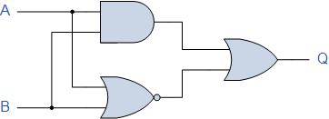

- Find the Boolean algebra expression for the following system.
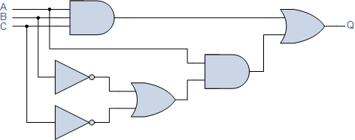
- Draw the circuit diagram to implement the expression
$X= (A+B)(\overline{B}+C)$
Useful tips. This expression was created in Word by a) Insert , b)Equation, c) Accent, d) Overbar
To get XOR symbol, type 2295 then press Alt/X
- Draw the circuit diagram to implement the expression
$X= \overline{A}BC(\overline{A+D})$

Truth Tables for the Laws of Boolean
Boolean  Expression | Description | Equivalent  Switching Circuit | Boolean Algebra  Law or Rule
A + 1 = 1 | A in parallel with  closed = "CLOSED" | 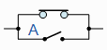 | Annulment
A + 0 = A | A in parallel with  open = "A" | 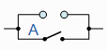 | Identity
A . 1 = A | A in series with  closed = "A" | 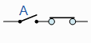 | Identity
A . 0 = 0 | A in series with  open = "OPEN" | 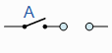 | Annulment
A + A = A | A in parallel with  A = "A" | 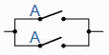 | Idempotent
A . A = A | A in series with  A = "A" | 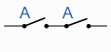 | Idempotent
NOT A = A | NOT NOT A  (double negative) = "A" |  | Double Negation
A + A = 1 | A in parallel with  NOT A = "CLOSED" | 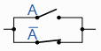 | Complement
A . A = 0 | A in series with  NOT A = "OPEN" | 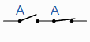 | Complement
A+B = B+A | A in parallel with B =  B in parallel with A | 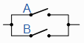 | Commutative
A.B = B.A | A in series with B =  B in series with A | 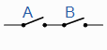 | Commutative
A+B = A.B | invert and replace OR with AND |  | de Morgan’s Theorem
A.B = A+B | invert and replace AND with OR |  | de Morgan’s Theorem

Answers to Exercise
- 
 